IFRS 16

REPORT

X. Background

IFRS 16 supersedes IAS 17 Leases (and related Interpretations) and is effective from 1 January 2019.   
The IASB and the US national standard-setter, the Financial Accounting Standards Board (FASB), have been working jointly to improve the accounting for leases in International Financial Reporting Standards (IFRS) and US Generally Accepted Accounting Principles (US GAAP). IFRS 16 completes the IASB’s project to improve financial reporting for leases.

X.Objective and scope of IFRS 16

The premise of IFRS 16 is simple: to bring all companies’ leases onto their balance sheets for 2019 accounting periods onwards.

The objective of IFRS 16 is to report information that

(a) faithfully represents lease transactions and

(b) provides a basis for users of financial statements to assess the amount, timing and uncertainty of cash flows arising from leases.

To meet that objective, a lessee should recognise assets and liabilities arising from a lease.

IFRS 16 introduces a single lessee accounting model and requires a lessee to recognise assets and liabilities for all leases with a term of more than 12 months, unless the underlying asset is of low value. A lessee is required to recognise a right-of-use asset representing its right to use the underlying leased asset and a lease liability representing its obligation to make lease payments.

X.Scope

The scope of IFRS 16 is generally similar to IAS 17 and includes all contracts that convey the right to use an asset for a period of time in exchange for consideration, except for licences of intellectual property granted by a lessor, rights held by a lessee under licensing agreements (such as motion picture films, video recordings, plays, manuscripts, patents and copyrights), leases of biological assets, service concession agreements and leases to explore for or use minerals, oil, natural gas and similar non-regenerative resources. There is an optional scope exemption for lessees of intangible assets other than the licences mentioned above

IFRS 16 includes detailed guidance to help companies assess whether a contract contains a lease or a service, or both. Under current guidance and practice, there is not a lot of emphasis on the distinction between a service or an operating lease, as this often does not change the accounting treatment.

The analysis starts by determining if a contract meets the definition of a lease. This means that the customer has the right to control the use of an identifiable asset for a period of time in exchange for consideration.

X. What is the new model?

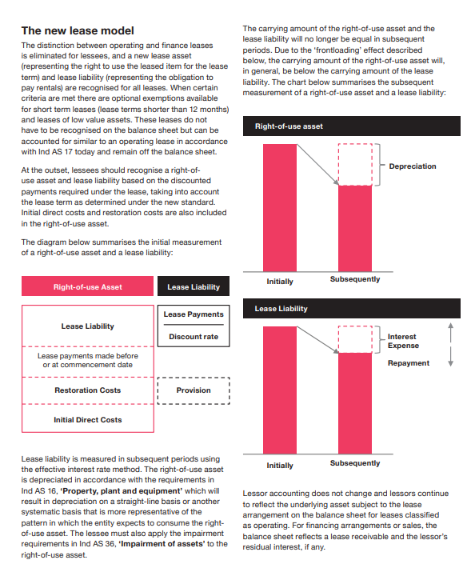

The distinction between operating and finance leases is eliminated for lessees, and a new lease asset (representing the right to use the leased item for the lease term) and lease liability (representing the obligation to pay rentals) are recognised for all leases*

The key elements of the new standard and the effect on financial statements are as follows:

• A ‘right-of-use’ model replaces the ‘risks and rewards’ model. Lessees are required to recognise an asset and liability at the inception of a lease.

• All lease liabilities are to be measured with reference to an estimate of the lease term, which includes optional lease periods when an entity is reasonably certain to exercise an option to extend (or not to terminate) a lease.

• Contingent rentals or variable lease payments will need to be included in the measurement of lease assets and liabilities when these depend on an index or a rate or where in substance they are fixed payments. A lessee should reassess variable lease payments that depend on an index or a rate when the lessee remeasures the lease liability for other reasons (for example, because of a reassessment of the lease term) and when there is a change in the cash flows resulting from a change in the reference index or rate (that is, when an adjustment to the lease payments takes effect).

• Lessees should reassess the lease term only upon the occurrence of a significant event or a significant change in circumstances that are within the control of the lessee.

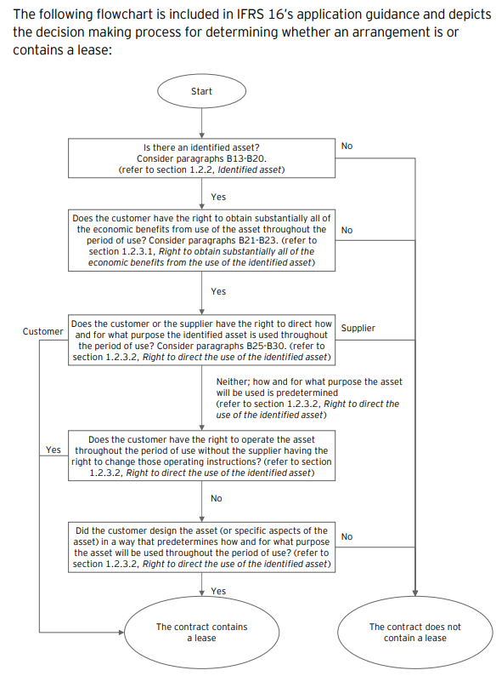

Current position

Currently, under IFRS and UK GAAP, leases are treated in one of two ways, depending on the balance of risk and reward of ownership of the underlying asset under the lease contract:

* **Finance lease:** when substantially all the risk and reward transfers to the lessee, the present value of lease payments is recognised as a liability on the balance sheet with a corresponding asset;
* **Operating lease**: when significant risk and reward remains with the lessor, the lessee recognises the rental or lease expense in the profit and loss account, as it falls due, with no balance sheet impact.

Under current practice, most non-specialised property leases are classified as operating leases, with no liability arising on the occupier’s balance sheet, and only “in-year” lease costs (ie rent and service charges) are recognised in the income statement.

How the Variables will be affected ?

* The new standard will affect virtually all commonly used financial ratios and performance metrics such as gearing, current ratio, asset turnover, interest cover, EBITDA, EBIT, operating profit, net income, EPS, ROCE, ROE and operating cash flows. These changes may affect loan covenants, credit ratings and borrowing costs, and could result in other behavioural changes. These impacts may compel many organisations to reassess certain ‘lease versus buy’ decisions.
* • Balance sheets will grow, gearing ratios will increase, and capital ratios will decrease. There will also be a change to both the expense character (rent expenses replaced with depreciation and interest expense) and recognition pattern (acceleration of lease expense relative to the recognition pattern for operating leases today).
* • Entities leasing ‘big-ticket’ assets – including real estate, manufacturing equipment, aircraft, trains, ships, and technology – are expected to be greatly affected. The impact for entities with numerous small leases, such as tablets and personal computers, small items of office furniture and telephones might be less as the IASB offers an exemption for low value assets (assets with a value of $5,000 or less when new). Low value assets meeting this exemption do not have to be recognised on the balance sheet
* The cost to implement and continue to comply with the new leases standard could be significant for most lessees. Particularly if they do not already have an in-house lease information system.

After IFRS 16 Impact

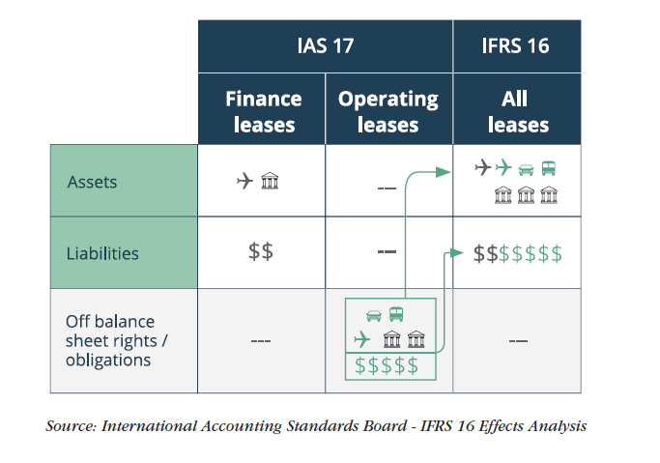  
IFRS 16 – Leases

The new leasing standard released by IASB removes the distinction between finance and operating leases for lessees. For lessees, all leases will be recorded on the balance sheet as liabilities, at the present value of the future lease payments, along with an asset reflecting the right to use the asset over the lease term.

Two possible exemptions are available for leases with a maximum term of twelve months or less and leases of low value assets

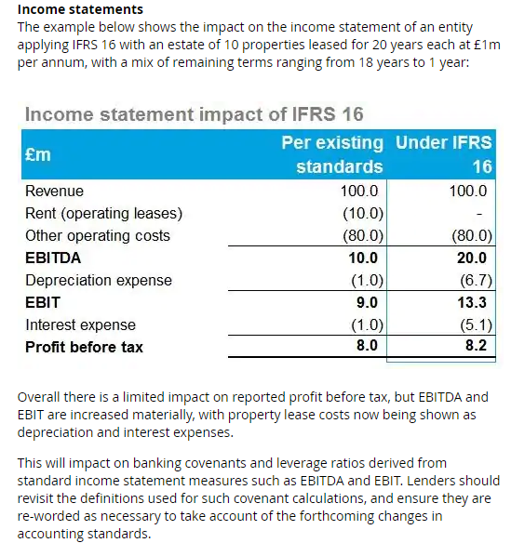

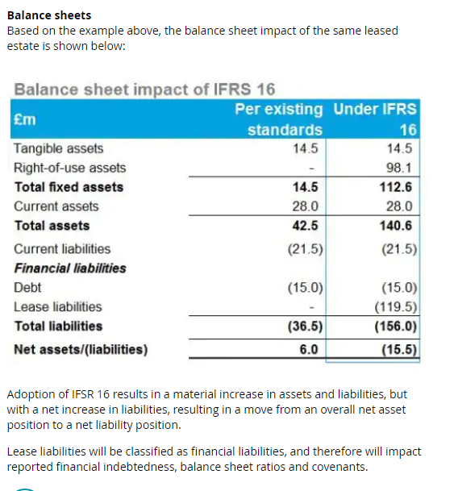

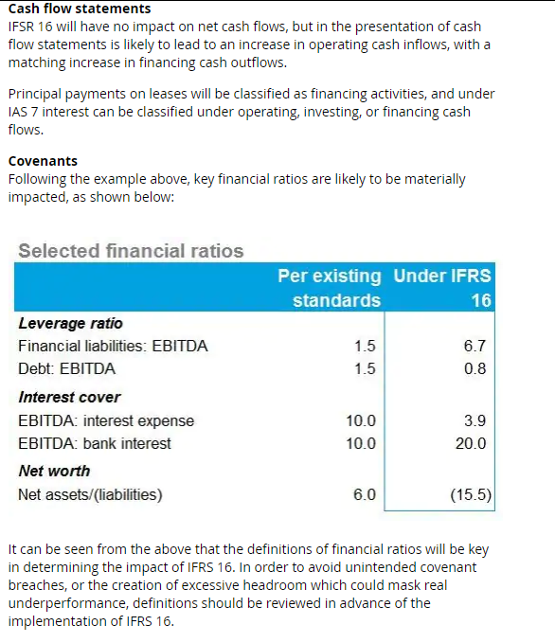

Source : <https://www2.deloitte.com/uk/en/pages/audit/articles/ifrs-16-leases.html>

Impact of IFRS 16 On Retail Industry

Although virtually every industry uses leasing as a means to obtain access to assets, the type and volume of assets that they lease, and the terms and structures of these lease agreements differ significantly

Retail

Retailers are heavy users of real estate

Retaily industry majorly uses leases for their stores. They are likely to experience major impacts when implementing the new leases standard:

* Renewal options – leasing real estate is retailers’ core business and determining and reassessing when a retailer has an economic incentive to renew a retail lease location may require substantial judgement.
* Variable payments linked to index or rate – retailers need to put systems in place to estimate and remeasure variable payments linked to an index at the spot rate for each reporting period (e.g. CPI).
* Separating lease and non-lease elements – retailers will need to separate service charges (e.g. administrative/utilities/marketing) from lease elements with many landlords – for example, with shop-in-shop leases and large retail outlets

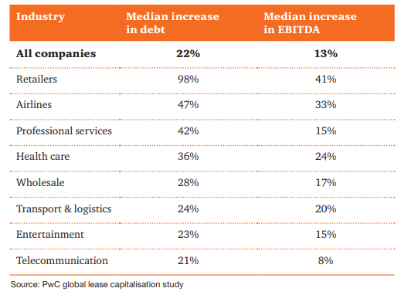

* Most of such leases are in the form of leases for premises, retail outlets and IT equipment. Leases of premises and retail outlets typically offer renewal options, and often involve variable rentals. This variability is commonly due to inflation adjustments and contingent rentals in some locations where the property owner has a vested interest in the performance of the business.
* Historically, such leases have been considered as operating leases, and have not therefore had any impact on the balance sheet. The amount recorded in the income statement was typically on a straight line basis and included in operating expenses.
* The new lease standard will not only have an impact on the balance sheet, but also on the operating costs, with a split of the expense between operating and finance costs.
* Retailers, who often lease many properties to use as retail spaces would, in particular, be impacted by this change because currently these leases of properties are not included as liabilities in the financial statements of retailers. Going forward, the retailers would now recognise these leases as a right-of-use asset and a corresponding lease liability in the statement of financial position. It should be noted that the right-of-use asset is a non-current asset, whereas the liability would be split into a current and a non-current portion.
* Aletta discusses the impact of adopting IFRS 16 on the statements of financial position, profit or loss and cash flows, including:
* IFRS 16 resulting in larger interest expense being taken through the statement of profit or loss at the start of the lease period
* That the reduction in the lease liability recognised would not match the depreciation profile of the right-of-use asset
* A portion of the lease liability will be classified as current, resulting in a reduction in the current ratio
* The cash flow nature of lease payments changes from operating to financing (amounts paid that are attributed to interest are a policy choice).
* As a result of IFRS 16 implementation, net debt across the S&P Euro 350 largest listed European corporates is expected to increase by 16% to €306bn. This figure will be heavily skewed towards companies in sectors such as retail, transport and aviation. However, it should be noted there will be no cash impact on companies once IFRS 16 comes into force and the rating agencies have already factored in the risk.
* Retailers such as Sainsbury’s, Marks & Spencer, and Tesco typically lease a large footprint of real estate for their stores and distribution centres as well as IT assets such as servers, storage, and data centre equipment to support their e-commerce operations.
* 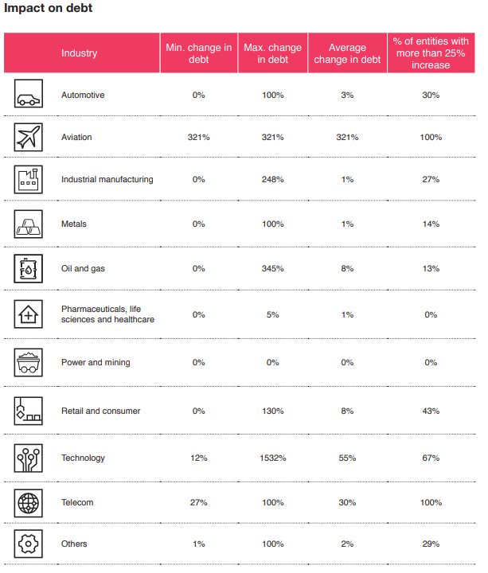
* 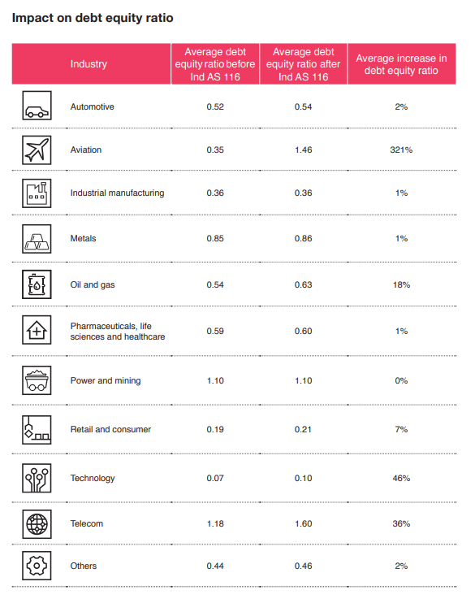
* 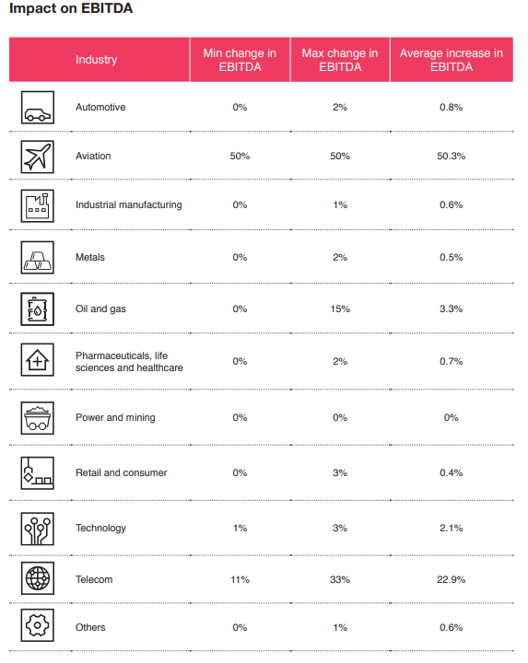

IFRS 16 Impact on Individual Retail Companies in Europe

|  |  |  |  |  |
| --- | --- | --- | --- | --- |
| Key Balance Sheet Elements Comparison  (€ million) or % Change over previous year | Morrisons (FY/19) | Tesco Plc (FY/19) | Alhord Delhaize(Q1/19) | Casino Groupe (H1/19) |
| Right-of-use assets | 929 | 7,527 | 7,027 | 4,982 |
| Current assets | 8.8% | -1% | 1% | 1% |
| Total assets | 7.6% | 13% | 19% | 14% |
| Total equity | -6.6% | -12% | -4% | -3% |
| Non-current financial liabilities | 1.6% | -2% | 4% | -0.41% |
| Total equity and liabilities | -6.6% | -12% | 19% | 14% |

**Balance Sheet Observations**

1.As we can observe the Right-Of-Use Assets sections which has been added to each of the following companies balance sheet has increased the Assets by that amount which has also led to changes in

-An Increase in Total Assets for all of the companies   
-An Overall effect of change on Total Equity and Liabilities

2.A Change in the non-current financial liabilities section of the companies ,this impact is majorly dependent upon the lease liabilities which a company has and varies company to company according to it.

|  |  |  |  |  |
| --- | --- | --- | --- | --- |
| Key Metrics for Cash Flow (€ million) or % Change over previous year | Morrisons (FY/19) | Tesco Plc (FY/19) | Alhord Delhaize(Q1/19) | Casino Groupe (H1/19) |
| CFO | 16% | 18.2% | -1.0% | -14% |
| Lease Payment | 122% | 193.3% | -44.4% | 35% |
| Repayment of New or Extra Lease Obligations under IFRS 16 | +69 | +588 | +320 | +343 |

**Cash Flow Observations**

1.An Decrease/Increase in the CF from Operations can be attributed to the payment for leases which were earlier made under the Core Operating Expenses

2.An Increase in the Lease Payments amount is because of the IFRS 16 leases expense recognition clauses

3.Extra Lease Obligation has been added in the CFS of every company as an impact of IFRS 16.

|  |  |  |  |  |
| --- | --- | --- | --- | --- |
| Income Statement Element Comparison (€ million) or % Change over previous year | Morrisons (FY/19) | Tesco Plc (FY/19) | Alhord Delhaize(Q1/19) | Casino Groupe (H1/19) |
| Revenue | 0.00% | 0% | 0.0% | 0% |
| COGS | -0.26% | -1% | 0.0% | -0.24% |
| Operating Proft | 9.64% | 23% | 8.5% | 25.7% |
| Finance Cost | 57.73% | 103% | 87.5% | 82.5% |
| Finance Income | 4.55% | 14% | 200.0% | -1.9% |
| Tax | -7.89% | -2% | -1.9% | -34.8% |

**Income Statement Observations**

1.No Impact on Revenue

2.As observed by the table ,COGS have been reduced by a -1% to 0.24% range ,which can be used to draw a conclusion that would also follow to a higher G/P number which may lead to better Margins for majority of the players.

3.Operating Profit has increased from 8.5% to 25.7% ,as an impact of Lease as an expenses removed from the Operating Expenses which leads to high Operating Margins

4.Finance Cost and Income has seen an increase because of the firms accounting lease payments received or expensed under this head which were earlier kept off balance sheet.